Spring Has Arrived!
Welcome to our second quarter issue of the Silver Bulletin for 2022. As we move out of winter and into spring, we look for the signs of change that signal the arrival of spring. Longer warmer days and new signs of life in nature affirm that spring has come. Spring is also a good time to review some important changes that can affect our lives.

National Healthcare Decision Day is April 16. National HealthCare Decisions Day (NHDD) is a nationwide initiative that encourages adults of all ages to plan ahead of a health crisis. When making health care decisions it is important to put your wishes in writing. Family members and loved ones can have peace of mind knowing what your wishes are. We also allow our caregivers to be our voice and advocates when we are unable to do it ourselves. Now is the perfect time to review your advanced care planning documents. If you have not thought about it, April 16 is a good time to start. If you are interested in starting, or have questions about your current Advanced Health Care Directive, please call the Office of Aging at (808) 961-8626. Our Aging and Disabilities Specialist (ADS) will be happy to connect you to the Community First Foundation for assistance.


This year is the first election year after the decennial census count. We want to encourage everyone to exercise his or her right by casting your vote this year. To help guarantee your right, it is important that your voter registration information is current and correct. Voter Notification Postcards also known as the “Yellow Card” will be arriving at households during the 3rd or 4th week in April. Only properly registered voters will receive Voter Notification Postcards. It is very important that you verify your information is correct so you can receive your ballot. If you do not receive your “Yellow” card by mid-May and believe that you have registered to vote, please contact the Elections Office at (808) 961-8277. You may also visit their website at www.elections.hawaiicounty.gov.

As we enjoy getting back to normal, let us remember to do the following:

Wash your Hands, and wear a MASK if you are not feeling well
ADRC CORNER
The Aging and Disability Resource Center (ADRC) is an access point for older individuals, caregivers and people with disabilities.
The ADRC provides information, resource awareness, and assists with connecting people to services and supports island-wide. Aging and Disability Service Specialists are available to answer questions and provide assistance in our Hilo (808-961-8626) and Kailua-Kona (808-323-4390) offices Monday through Friday from 7:45am-4:30pm (closed on holidays).
“Pay it Forward”
Alice Bratton –Aging and Disability Services Specialist I (West Hawaii)
I receive many acts of kindness in the course of a day. Often the kindness is an expression of gratitude or appreciation, for which I am grateful! These acts of kindness enhance my connection to folks, which I find emotionally, psychologically, socially, and spiritually nourishing. As I contemplate acts of kindness, I see how easily one act of kindness generates a responding act of kindness. I believe these chains of gratitude and joy amplify our connection to others and community. How beautiful!
Keanalu Chartrand- Aging and Disability Services Specialist I (East Hawaii)
I believe acts of kindness come in many forms. I feel that most acts of kindness I received was when my father passed away. I was in the grieving state and my father’s passing was still fresh in my mind. I took my family out to dinner and as I was trying to pay the bill the waiter stated that the bar tender paid my bill. He walked up to me and said “I’m sorry for your loss and felt your pain when I found out.” He was a friend, but on that day he became a really good friend. It wasn’t about the money. It was the gesture of kindness he did. I repaid him when I helped him with his wedding and did the imu with him. When I was going through one of the hardest things I’ve ever went through, people that cared for me showed me kindness by talking to me and trying to use empathy to help me go through the feelings of loss that I felt and had to learn to deal with.
Westley Tanigawa- Aging and Disability Services Specialist II (East Hawaii)
We are fortunate to have many blessings that come our way. They come so often and regularly that they can be considered as an expectation. But it takes work and humility to remember and appreciate the goodness that comes our way, the people that brought them and the many forms that it can take that blesses our lives. Usually, it is the blessings that come during our hardest struggles that remain in our hearts and minds for many years.

One of my profound memories of a good deed that made a significant impact in my life’s experience was when I moved to San Francisco. I was not happy with my life in Hawaii and wondered if Akua wanted me to change my path in life. I talked to a friend of mine in San Francisco discussed my thoughts of moving there. She informed me that she was thinking of moving to Arizona in a few weeks but did not want to give up her apartment that she rented in case she wanted to return in a year or two. She offered to sublet it to me.

I prayed about it, packed my bags and moved on April 1, 1991. The cards were stacked against me: I had no job, unemployment in California was almost 10%, and I had enough money to pay the first month’s rent. I had to find a job in a month or I would be in big trouble. San Francisco was beautiful the morning I arrived—warm, clear blue skies, and so sunny. I immediately began my job search after I dropped my belongings in my new apartment. I went almost everywhere to apply for a job and submit my resume. There were some agencies that liked me and I was interested in that particular job. But they could not offer me the job until the deadline for in-house applicants was met. In each of those cases, I ended up as the first runner up. Now I know how Miss America’s first runner up felt.

During a job search, I went to an employment agency. I was reluctant to apply with this type of agency because they charge a significant fee for finding a person a job. While I was being interviewed, a man passed by and heard me speaking to the interviewer. He turned around and said, “You’re from Hawaii”. I nodded, yes.
He took me from that meeting and to his office, looked at my resume, and wrote about 6 names of people and their telephone numbers for me to call. He sent me off with, “Call them. One of them will find you a job”. There was no fee for his service. I did not even get his name. But one of the people on the list offered me a job at the end of the month and wanted me to start immediately. My first paycheck came in time to pay my rent. I was saved. Prayers were answered… and more. The job paid me more than I could have expected. It required me to tap beyond my diverse experiences. This job was the first of its kind nation-wide so I had no models to follow. I knew I had a huge responsibility to get it off the ground and running, but I met many wonderful people who were helpful and so supportive of me working in San Francisco. I could not help but succeed. I felt like I died and went to heaven. I gave thanks to Akua and committed to spreading goodness in return.

I regret that through my frantic search for a job, I did not have the sense to record the address or phone number of the employment agency where that lifesaving gentleman worked. I wanted to thank that man who was so helpful. But I remember an old saying: “For every good deed done to you, you have to do it 10,000 times to others.” I realize that it will take more than a lifetime for me to accomplish this mission, but it is a mission that I gratefully accept.

Leilani Westergard- Aging and Disability Services Specialist I (East Hawaii)
The Dalai Lama is quoted “Be kind whenever possible. It is always possible.” Kindness starts somewhere. It starts with me. It starts with you. It really doesn’t take very much to do our tiny part to increase the good in this world. A little kindness goes a long way, often further than we realize.
We often say “Lucky We Live Hawaii”, and it is so very true. Especially NOW.
Let us move the world with ripples of Aloha. Ripples that start small…beginning with kindness in our words and compassion in our actions to those around us. Ripples that stretch far and wide as the power of our Aloha Spirit inspires others to generate their own ripples of Aloha.
Meredith Catalini- Aging and Disability Services Manager
Paying it forward is a practice that I appreciate whether I am on the “getting or giving” side. There are simple moments in time that remain in my memory because someone took a second to pass a kind gesture, action or appreciative word my way. It is amazing how the smallest of things can lift us up. The intention in which these have been given, pushes me to also be intentional about paying it forward to others.
“When you learn, teach. When you get, give” Maya Angelou


Older adults play vital, positive roles in our communities – as family members, friends, mentors, volunteers, civic leaders, members of the workforce, and more. Just as every person is unique, so too is how they age and how they choose to do it – and there is no “right” way. That’s why the theme for Older Americans Month (OAM) 2022 is Age My Way. This year’s theme focuses on how older adults can age in their communities, living independently for as long as possible and participating in ways they choose.
Diverse communities are strong communities. Ensuring that older adults remain involved and included in our communities for as long as possible benefits everyone. While Age My Way will look different for each person, here are common things everyone can consider:
· Planning: Think about what you will need and want in the future, from home and community-based services to community activities that interest you.
· Engagement: Remain involved and contribute to your community through work, volunteer, and/or civic participation opportunities.
· Access: Make home improvements and modifications, use assistive technologies, and customize supports to help you better age in place.
· Connection: Maintain social activities and relationships to combat social isolation and stay connected to your community.

This year, the Hawaii County Office of Aging will not be hosting our traditional luncheon in celebration of Older Americans Month due to the ongoing COVID-19 pandemic. Like last year, the Hawaii County Office of Aging will be accepting nominations to recognize Outstanding Older Americans who continue to strengthen their communities. Nominees and winners will be recognized by the Hawaii County, the State Executive Office on Aging, and the Governor’s office. Our office will continue to release information and details. Stay Tuned!

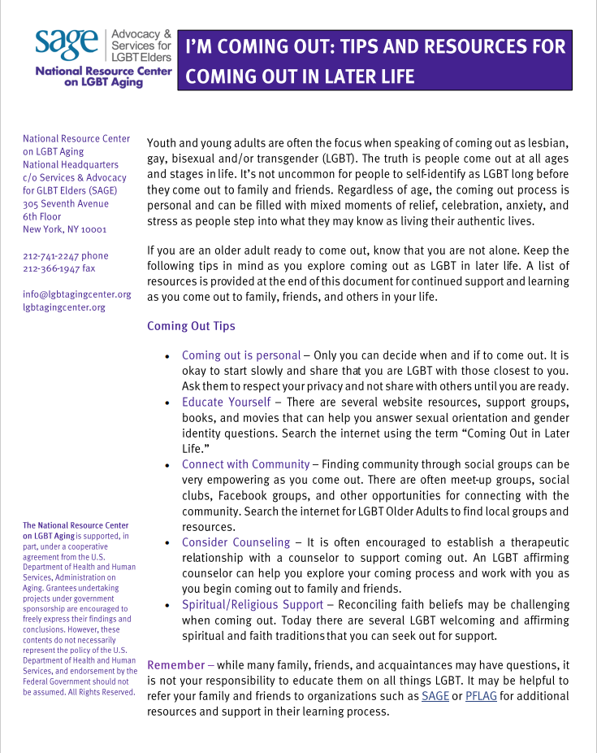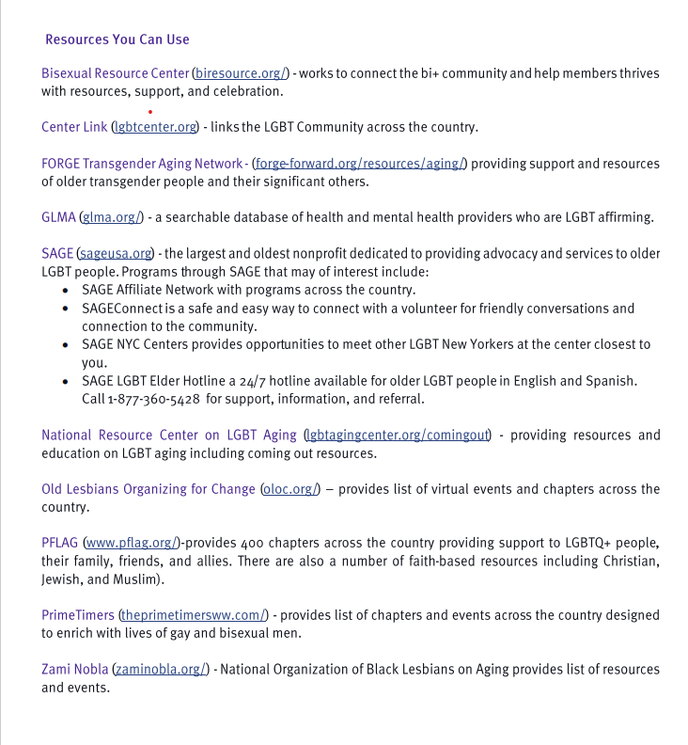
The Hawaii County Office of Aging is proud to support every individual in our community. We provide access to our activities without regard to race, color, national origin, age, gender, orientation, religion, or disability.
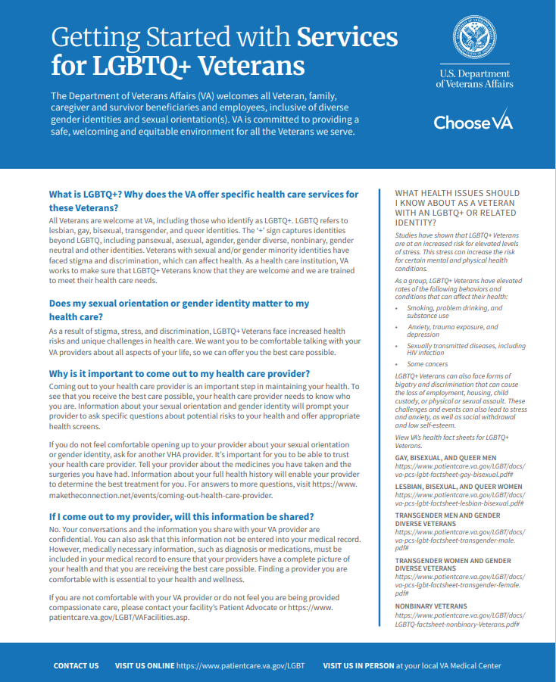

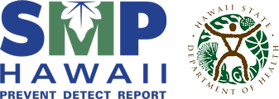
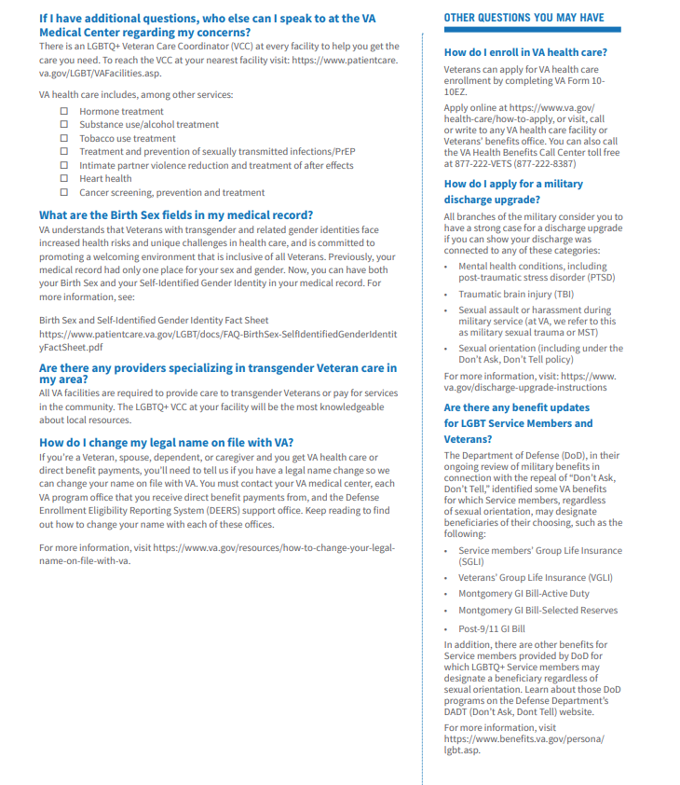SENIOR MEDICARE PATROL (SMP HAWAII)
The SMP Hawaii (http://smphawaii.org) provides information to detect, prevent, and report Medicare fraud, abuse, and waste. Protecting your personal information is the best line of defense in the fight against healthcare fraud and abuse. However, even when you do everything right, there is a chance that you could be a target of healthcare fraud. So if you suspect errors, fraud, or abuse, report it immediately!

Call SMP Hawaii at 586-7281 on Oahu. On the neighbor islands, call SMP Hawaii toll-free 1-800-296-9422.

LEARN TO DETECT POTENTIAL ERRORS, FRAUD, AND ABUSE
Always review your Medicare Summary Notice (MSN) and Part D Explanation of Benefits (EOB) for mistakes. Access to your current Medicare account is available 24 hours a day, simply visit www.MyMedicare.gov

Look for three things on your billing statement:
- Charges for something you didn’t get;
- Billing for the same thing twice;
- Services that were not ordered by your doctor.

IF YOU SUSPECT ERRORS, FRAUD, OR ABUSE

If you have questions about information on your Medicare Summary Notice or Part D Explanation of Benefits, call your doctor or health plan first.
If you are not comfortable calling your doctor or health plan, or you are not satisfied with the response you get, call SMP Hawaii.

BECOME A SMP HAWAII VOLUNTEER
SMP Hawaii relies on volunteers to educate and empower older adults to take an active role in the detection and prevention of health care fraud and abuse in Hawaii.
To become a SMP Hawaii volunteer, please call the Executive Office on Aging at 586-0100 (Oahu) for more information
Kupuna Cards are issued to County of Hawai‘i Residents 55 and older. Please bring a Valid ID (Examples are Hawai‘i Driver’s License, Hawai‘i State ID, Military ID, Passport, Birth Certificate and Social Security Card). Hilo and Kona offices will issue Kupuna Cards five days a week, except on holidays.

APRIL
04, Mon. | Hilo | Kamana Senior Center | 1:00 – 3:00 p.m.
06, Wed. | Honoka‘a | Malama Market | 11:00 – 1:00 p.m.
11, Mon. | HOVE | St. Jude’s Church | 9:00 – 11:00 a.m.
11, Mon. | Kohala | Kohala CSE “Old Bank of Hawai‘i Building” | 9:00 – 11:00 a.m.
12, Tues. | Waimea | Lily Yoshimatsu Senior Center | 9:00 – 11:00 a.m.
12, Tues. | Kona | Walmart, Kailua-Kona | 9:00 – 12:00 p.m.
12, Tues. | Puna | Pāhoa Senior Center | 12:00 – 2:00 p.m.
13, Wed. | Honoka‘a | Hale Hau‘oli Senior Center | 9:00 – 11:00 a.m.
21, Thurs. | Kona | Keauhou Shopping Center (outside KTA) | 11:00 – 1:00 p.m.
Mon.-Fri., except on holidays | Kona | West Hawai‘i Civic Center - Building B | 2:00 – 3:30 p.m.
MAY
04, Wed. | Honoka‘a | Malama Market | 11:00 – 1:00 p.m.
09, Mon. | Ka‘ū | Pāhala HI Housing Center | 9:00 – 10:00 a.m.
09, Mon. | Ka‘ū | Nā‘ālehu Community Center | 11:00 – 12:00 p.m.
09, Mon. | Kohala | Kohala CSE “Old Bank of Hawai‘i Building” | 10:00 – 12:00 p.m.
10, Tues. | Waimea | Lily Yoshimatsu Senior Center | 9:00 – 11:00 a.m.
10, Tues. | Kona | Walmart, Kailua-Kona | 9:00 – 12:00 p.m.
10, Tues. | Puna | Pāhoa Senior Center | 12:00 – 2:00 p.m.
11, Wed. | Honoka‘a | Hale Hau‘oli Senior Center | 9:00 – 11:00 a.m.
11, Wed. | Puna | Kea‘au Community Center | 2:00 – 3:00 p.m.
Mon.-Fri., except on holidays | Kona | West Hawai‘i Civic Center - Building B | 2:00 – 3:30 p.m.
JUNE
01, Wed. | Honoka‘a | Malama Market | 11:00 – 1:00 p.m.
06, Mon. | Hilo | Kamana Senior Center | 1:00 – 3:00 p.m.
08, Wed. | Honoka‘a | Hale Hau‘oli Senior Center | 9:00 – 11:00 a.m.
13, Mon. | HOVE | St. Jude’s Church | 9:00 – 11:00 a.m.
13, Mon. | Kohala | Kohala CSE “Old Bank of Hawai‘i Building” | 10:00 – 12:00 p.m.
14, Tues. | Waimea | Lily Yoshimatsu Senior Center | 9:00 – 11:00 a.m.
14, Tues. | Kona | Walmart, Kailua-Kona | 9:00 – 12:00 p.m.
14, Tues. | Puna | Pāhoa Senior Center | 12:00 – 2:00 p.m.
23, Thurs. | Kona | Keauhou Shopping Center (outside KTA) | 11:00 – 1:00 p.m.
Mon.-Fri., except on holidays | Kona | West Hawai‘i Civic Center - Building B | 2:00 – 3:30 p.m.

“To be yourself in a world that is constantly trying to make you something else is the greatest accomplishment.”
― Ralph Waldo Emerson
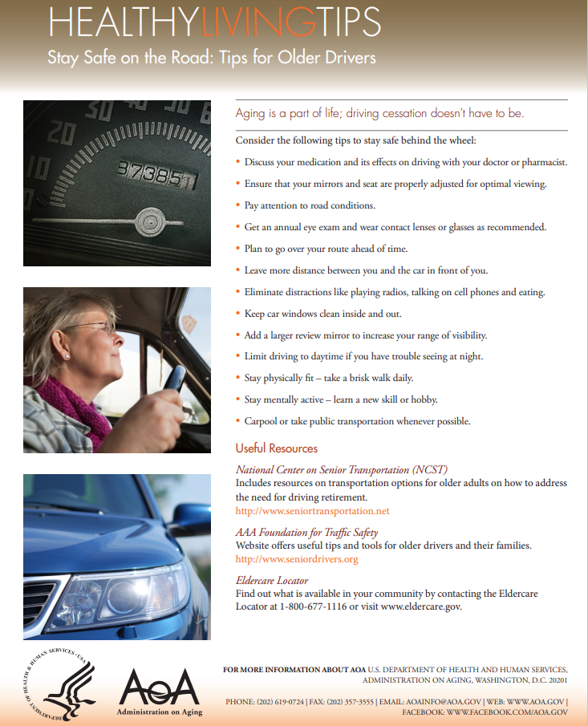


Lesbian, Gay, Bisexual, Transgender and Queer (LGBTQ) Pride Month is currently celebrated each year in the month of June to honor the 1969 Stonewall Uprising in Manhattan. The Stonewall Uprising was a tipping point for the Gay Liberation Movement in the United States. In the United States the last Sunday in June was initially celebrated as "Gay Pride Day," but the actual day was flexible. In major cities across the nation the "day" soon grew to encompass a month-long series of events. Today, celebrations include pride parades, picnics, parties, workshops, symposia and concerts, and LGBTQ Pride Month events attract millions of participants around the world. Memorials are held during this month for those members of the community who have been lost to hate crimes or HIV/AIDS. The purpose of the commemorative month is to recognize the impact that lesbian, gay, bisexual and transgender individuals have had on history-- locally, nationally, and internationally.


Chinese Savory Pancakes

INGREDIENTS
- 1 cup all-purpose flour
- 1 large egg
- 1 cup water
- ½ tsp salt (or salt to taste)
- 1 cup chopped green onions/chives
- 1 medium carrot (grated)
- 1 ½ cup cooked shrimp (chopped)
- 4 TBSP vegetable oil

DIRECTIONS
- In large bowl combine flour, egg, water, and salt. Stir to make a smooth batter (batter should have a thick, smooth consistency).
- Stir in vegetables and shrimp. Mix well.
- Heat about 2 TBSP of the vegetable oil in a frying pan. Pour/ladle about ¼ cup batter into pan for each pancake.
- Pan fry about 3-4 minutes. Flip pancakes and fry another 3-4 minutes or until golden brown and crisp.
- Remove pancakes and drain on paper towels. Do not overcrowd the pan. Fry in 2 batches.
- Serve warm with Thai sweet chili sauce, Chinese hot mustard, some sour cream, or your favorite sauce/topping.

*It is definitely possible to use a store-bought pancake mix instead of making the pancake batter from scratch. Follow the instructions on the package, add the veggies and shrimp, and then cook as instructed. You can also be adventurous and add kamaboku, corn, or crab meat to make this extra tasty. If I have cooked sweet potato or kalo, I dice it up into small cubes and add it to the batter. Enjoy!
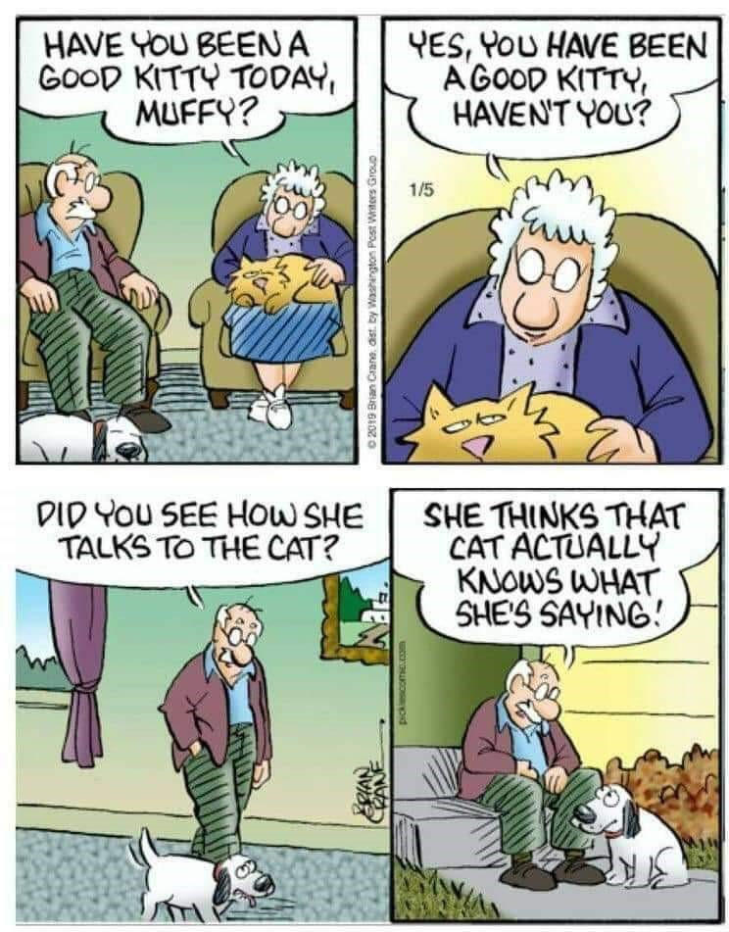
Small Kine Funny Kine
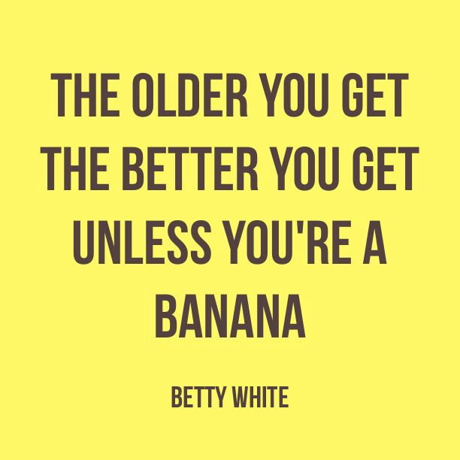

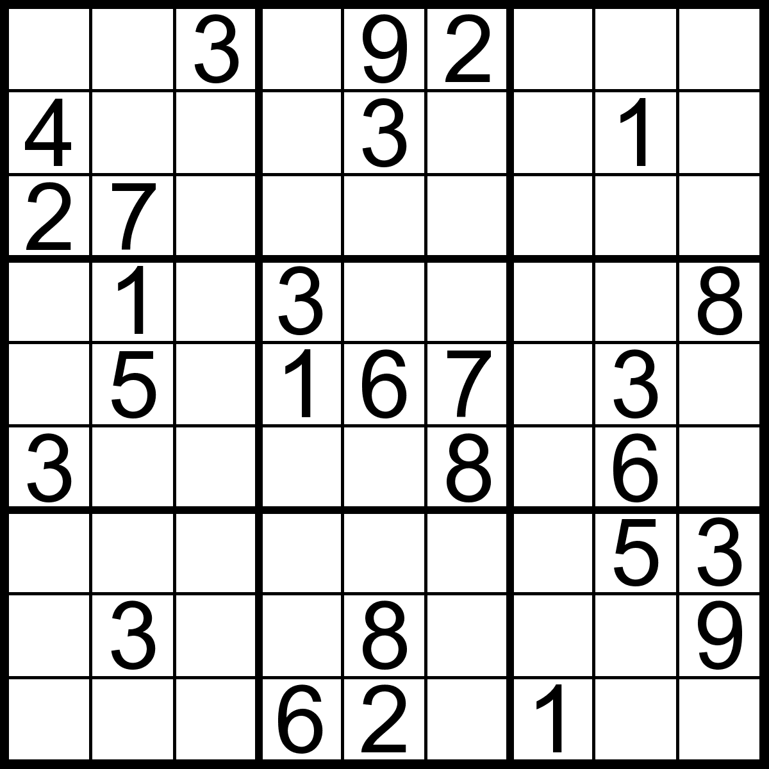
What is Bruce Lee’s favorite drink?
WATAH!

How does NASA organize their company parties?
They planet.

What do dentists call X-rays?
Tooth pics.

What do you call a big pile of kittens?
A meowntain

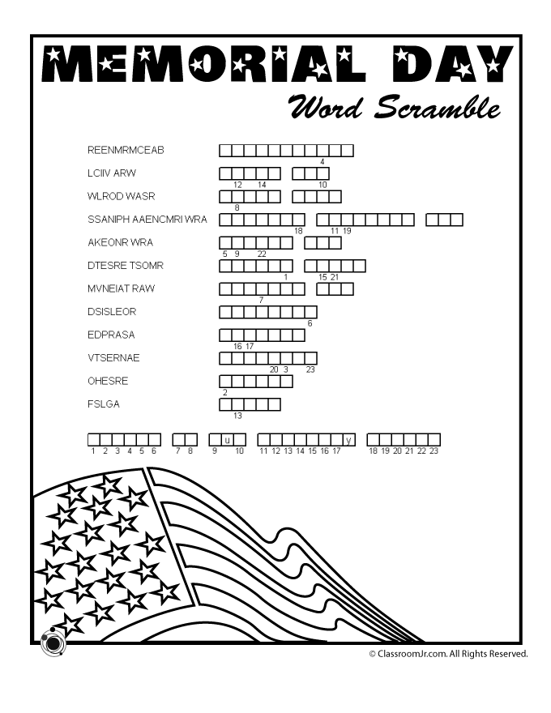
The Hawaii County Office of Aging and Aging and Disability Resource Center would like to welcome our newest Aging and Disability Services Specialist, Kimberlee Sato!

Also joining the team is Stuart Taketa, from the Senior Training and Employment Program!

Hawai’i County Office of Aging
1055 Kino’ole St.
Suite 101
Hilo, HI 96720
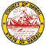

Thank you to our Senior Training & Employment Worker:
Stuart Taketa

HCOA programs are funded by the County of Hawai’i, the State of Hawai’i through the State Executive Office on Aging and through Older Americans Act Title III funds.

HILO OFFICE
1055 Kino'ole Street
Suite 101
Hilo, HI 96720
(808) 961-8600
Aging & Disability Resource Center
(808) 961-8626
KONA OFFICE
75-5044 Ane Keohokalole HWY
Building B
Kailua-Kona, HI 96740
(808) 323-4390
Aging & Disability Resource Center
(808) 323-4392

(808) 961-8626

HILO STAFF
Luana Ancheta-Kauwe | Information & Assistance Clerk
Meredith Catalini | Aging & Disability Services Manager
Keanalu Chartrand | Aging & Disability Services Specialist I
Lori Enomoto | Information & Assistance Clerk
Kelli Figueira | Clerk III
Clayton Honma | Aging Program Planner III
Keola Kenoi-Okajima | Aging Program Planner II
Christina Raine | Administrative Services Assistant I
Kimberlee Sato | Aging and Disability Services Specialist I
Wesley Tanigawa | Aging & Disability Services Specialist II
Leilani DLG Westergard | Aging & Disability Services Specialist I
Jolean Yamada | Aging & Disability Services Manager
KONA STAFF
Alice Bratton | Aging & Disability Services Specialist I
Bernie Canda | Information & Assistance Clerk
Debbie Wills | Aging Program Planner II

HAWAI’I COUNTY OFFICE OF AGING
Executive on Aging William Farr III

